5. Проектирование и разработка графовой базы данных

5.1. Понятие и назначение графовых баз данных
Графовая база данных — разновидность баз данных с реализацией сетевой модели в виде графа и его обобщений. Графовая СУБД — система управления графовыми базами данных.
Neo4j — графовая система управления базами данных с открытым исходным кодом, реализованная на Java.

Логическая модель
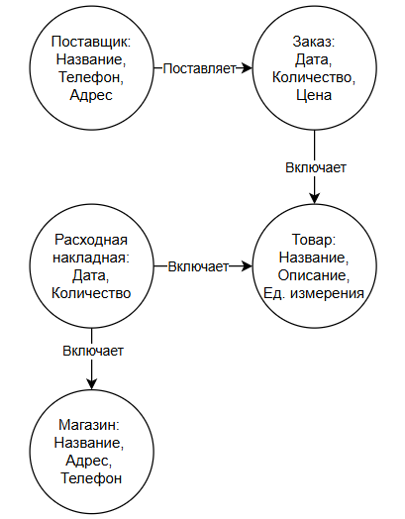
Рис. 85 «Логическая модель»

Создание прототипа базы данных
Создание происходит при помощи запросов Cypher запросов и основывался на БД из MS SQL.
CREATE (:Supplier {
id_supplier: 1,
Name: 'Молочный завод',
Phone: '83652753657',
Address: 'Москва'
});
CREATE (:Supplier {
id_supplier: 2,
Name: 'Хлебозавод №1',
Phone: '82647489374',
Address: 'Санкт-Петербург'
});
CREATE (:Shop {
id_shop: 1,
Name: 'Свежий выбор',
Phone: '83665873434',
Address: 'Кемерово'
});
CREATE (:Shop {
id_shop: 2,
Name: 'Вкусный дом',
Phone: '84627502355',
Address: 'Астрахань'
});
CREATE (:Product {
id_product: 1,
Name: 'Молоко ',
Description: 'Пастеризованное молоко жирностью 3,2%',
Unit: 'литр'
});
CREATE (:Product {
id_product: 2,
Name: 'Хлеб',
Description: 'Белый хлеб формовой',
Unit: 'штука'
});
CREATE (:Order {
id_order: 1,
Date: '2023-01-05',
Quantity: 40,
Price: 20000
});
CREATE (:Order {
id_order: 2,
Date: '2023-02-07',
Quantity: 80,
Price: 30000
});
CREATE (:Invoice {
id_invoice: 1,
Date: '2023-01-06',
Quantity: 20
});
CREATE (:Invoice {
id_invoice: 2,
Date: '2023-02-08',
Quantity: 50
});
MATCH (s:Supplier {id_supplier: 1}), (o:Order {id_order: 1})
CREATE (s)-[:PLACED]->(o);
MATCH (s:Supplier {id_supplier: 2}), (o:Order {id_order: 2})
CREATE (s)-[:PLACED_ORDER]->(o);
MATCH (o:Order {id_order: 1}), (p:Product {id_product: 1})
CREATE (o)-[:FOR_PRODUCT]->(p);
MATCH (o:Order {id_order: 2}), (p:Product {id_product: 2})
CREATE (o)-[:FOR_PRODUCT]->(p);
MATCH (sh:Shop {id_shop: 1}), (i:Invoice {id_invoice: 1})
CREATE (sh)-[:RECEIVED_INVOICE]->(i);
MATCH (sh:Shop {id_shop: 2}), (i:Invoice {id_invoice: 2})
CREATE (sh)-[:RECEIVED_INVOICE]->(i);
MATCH (i:Invoice {id_invoice: 1}), (p:Product {id_product: 1})
CREATE (i)-[:FOR_PRODUCT]->(p);
MATCH (i:Invoice {id_invoice: 2}), (p:Product {id_product: 2})
CREATE (i)-[:FOR_PRODUCT]->(p);
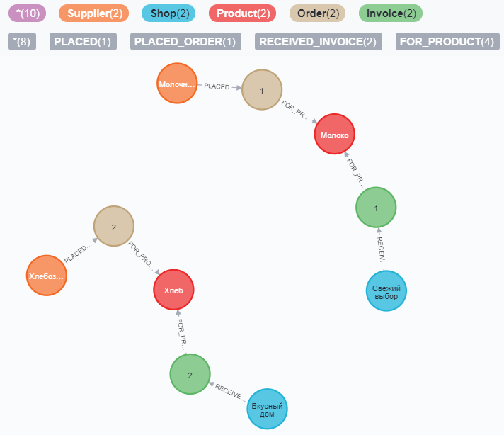
Рис. 86 «Графовое отображение концептуальной базы данных»

Разработка реальной базы данных
Код:
from neo4j import GraphDatabase
class Neo4jConnection:
def __init__(self, uri, user, password):
self.driver = GraphDatabase.driver(uri, auth=(user, password))
def close(self):
if self.driver is not None:
self.driver.close()
# Метод, который передает запрос в БД
def query(self, query, db=None):
assert self.driver is not None, "Driver not initialized!"
session = None
response = None
try:
session = self.driver.session(database=db) if db is not None else self.driver.session()
response = list(session.run(query))
except Exception as e:
print("Query failed:", e)
finally:
if session is not None:
session.close()
return response
conn = Neo4jConnection(uri="bolt://localhost:7687", user="Polina", password="1234")
#conn.query("CREATE OR REPLACE DATABASE Bavr")
query_string = '''
LOAD CSV WITH HEADERS FROM
'https://raw.githubusercontent.com/itz-poldnik/war/refs/heads/main/Supplier.csv'
AS line FIELDTERMINATOR ','
MERGE (supplier:Supplier {id_supplier: line.id_supplier})
ON CREATE SET supplier.Name = line.Name, supplier.Phone = line.Phone, supplier.Address = line.Address;
'''
conn.query(query_string, db='Bavr')
query_string = '''
LOAD CSV WITH HEADERS FROM
'https://raw.githubusercontent.com/itz-poldnik/war/refs/heads/main/Shop.csv'
AS line FIELDTERMINATOR ','
MERGE (shop:Shop {id_shop: line.id_shop})
ON CREATE SET shop.Name = line.Name, shop.Phone = line.Phone, shop.Address = line.Address;
'''
conn.query(query_string, db='Bavr')
query_string = '''
LOAD CSV WITH HEADERS FROM
'https://raw.githubusercontent.com/itz-poldnik/war/refs/heads/main/Product.csv'
AS line FIELDTERMINATOR ','
MERGE (product:Product {id_product: line.id_product})
ON CREATE SET product.Name = line.Name, product.Description = line.Description, product.Unit = line.Unit;
'''
conn.query(query_string, db='Bavr')
query_string = '''
LOAD CSV WITH HEADERS FROM
'https://raw.githubusercontent.com/itz-poldnik/war/refs/heads/main/Order.csv'
AS line FIELDTERMINATOR ','
MERGE (order:Order {id_order: line.id_order})
ON CREATE SET order.Date = line.Date, order.Quantity = toFloat(line.Quantity), order.Price = toFloat(line.Price);
'''
conn.query(query_string, db='Bavr')
query_string = '''
LOAD CSV WITH HEADERS FROM
'https://raw.githubusercontent.com/itz-poldnik/war/refs/heads/main/Invoice.csv'
AS line FIELDTERMINATOR ','
MERGE (invoice:Invoice {id_invoice: line.id_invoice})
ON CREATE SET invoice.Date = line.Date, invoice.Quantity = toFloat(line.Quantity);
'''
conn.query(query_string, db='Bavr')
# Связь Shop -> Invoice
query_shop_invoice = '''
LOAD CSV WITH HEADERS FROM 'https://raw.githubusercontent.com/itz-poldnik/war/refs/heads/main/Invoice.csv' AS line
MATCH (shop:Shop {id_shop: line.id_shop})
MATCH (invoice:Invoice {id_invoice: line.id_invoice})
MERGE (shop)-[:ISSUES]->(invoice);
'''
conn.query(query_shop_invoice, db='Bavr')
# Связь Order -> Supplier
query_order_supplier = '''
LOAD CSV WITH HEADERS FROM 'https://raw.githubusercontent.com/itz-poldnik/war/refs/heads/main/Order.csv' AS line
MATCH (order:Order {id_order: line.id_order})
MATCH (supplier:Supplier {id_supplier: line.id_supplier})
MERGE (order)-[:ORDERED_FROM]->(supplier);
'''
conn.query(query_order_supplier, db='Bavr')
# Связь Order -> Product
query_order_product = '''
LOAD CSV WITH HEADERS FROM 'https://raw.githubusercontent.com/itz-poldnik/war/refs/heads/main/Order.csv' AS line
MATCH (order:Order {id_order: line.id_order})
MATCH (product:Product {id_product: line.id_product})
MERGE (order)-[:CONTAINS_PRODUCT]->(product);
'''
conn.query(query_order_product, db='Bavr')
# Связь Order -> Shop
query_order_shop = '''
LOAD CSV WITH HEADERS FROM 'https://raw.githubusercontent.com/itz-poldnik/war/refs/heads/main/Order.csv' AS line
WITH line
WHERE line.id_shop IS NOT NULL AND line.id_shop <> ''
MATCH (order:Order {id_order: line.id_order})
MATCH (shop:Shop {id_shop: line.id_shop})
MERGE (order)-[:PLACED_IN]->(shop);
'''
conn.query(query_order_shop, db='Bavr')
# Связь Invoice -> Product
query_invoice_product = '''
LOAD CSV WITH HEADERS FROM 'https://raw.githubusercontent.com/itz-poldnik/war/refs/heads/main/Invoice.csv' AS line
MATCH (invoice:Invoice {id_invoice: line.id_invoice})
MATCH (product:Product {id_product: line.id_product})
MERGE (invoice)-[:INCLUDES_PRODUCT]->(product);
'''
conn.query(query_invoice_product, db='Bavr')
query_invoice_shop = """
LOAD CSV WITH HEADERS FROM 'https://raw.githubusercontent.com/itz-poldnik/war/refs/heads/main/Invoice.csv' AS line
MATCH (invoice:Invoice {id_invoice: line.id_invoice})
MATCH (shop:Shop {id_shop: toInteger(line.id_shop)})
MERGE (invoice)-[:SENT_TO]->(shop);
"""
conn.query(query_invoice_shop, db='Bavr')
Таблицы с данными:
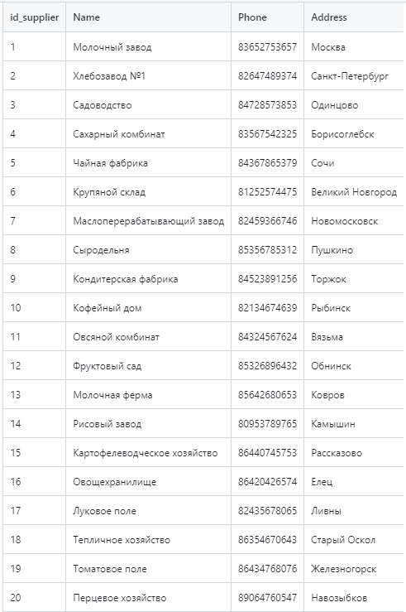
Рис. 87 «Таблица поставщики»
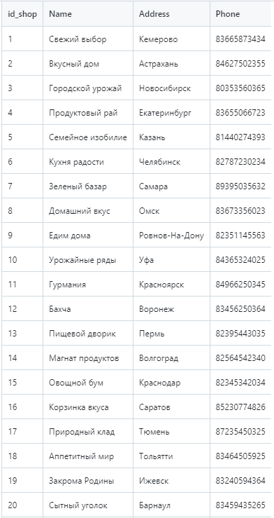
Рис. 88 «Таблица магазины»
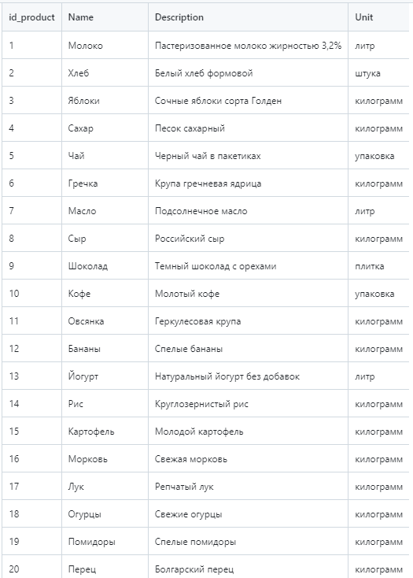
Рис. 89 «Таблица товары»
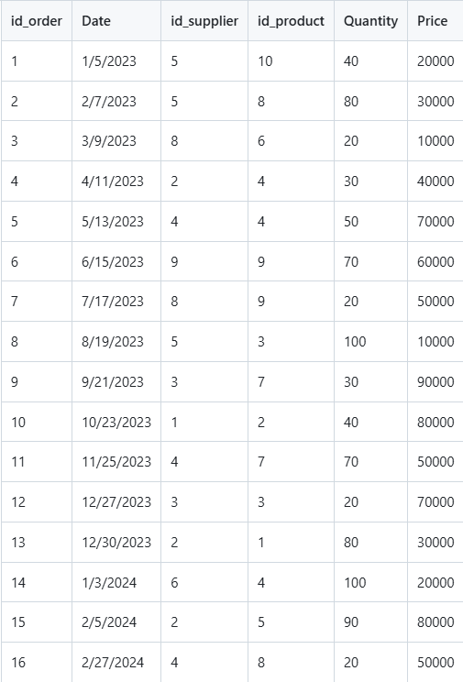
Рис. 90 «Таблица заказы»
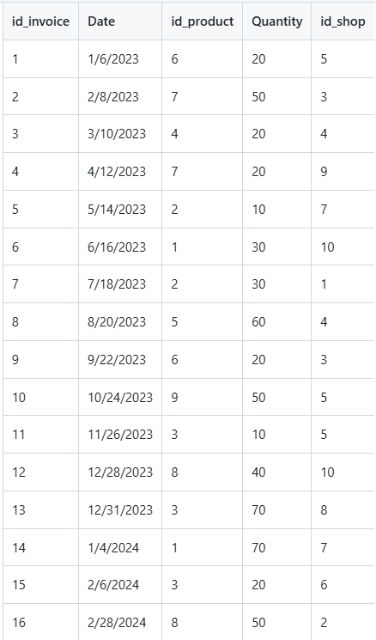
Рис. 91 «Таблица расходная накладная»
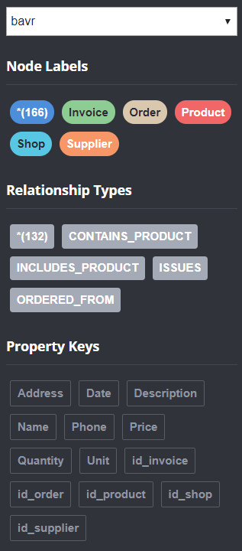
Рис. 92 «Содержание»

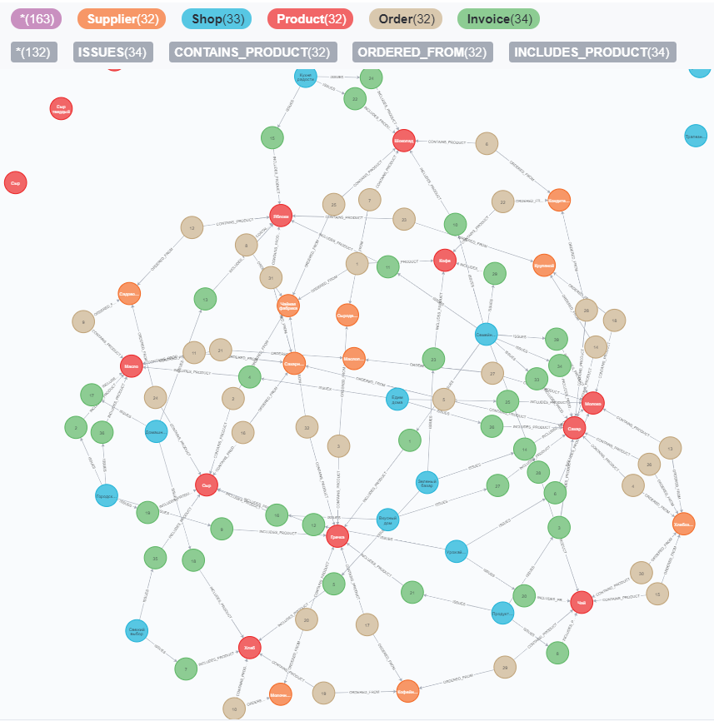
Рис. 93 «Схема Neo4j»

5.4.1. Запросы на выборку с условием
Выборка списка всех заказов и связанных с ними поставщиков и продуктов
MATCH (o:Order)-[:ORDERED_FROM]->(s:Supplier), (o)-[:CONTAINS_PRODUCT]->(p:Product)
RETURN o.id_order AS OrderID, o.Date AS Date, s.Name AS Supplier, p.Name AS Product, o.Quantity AS Quantity, o.Price AS Price
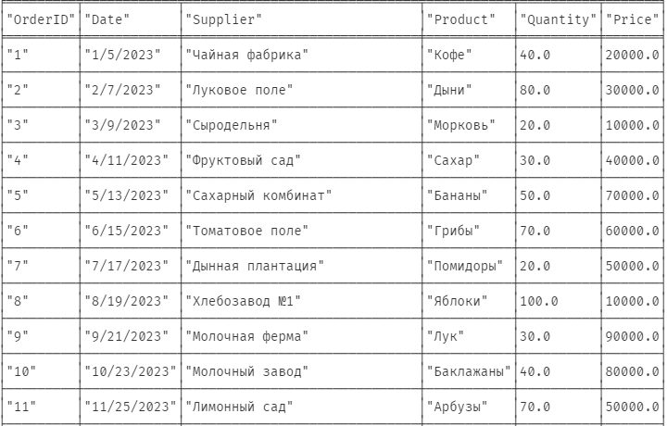
Рис. 94 «Заказы с поставщиками и продуктами»
Выборка общего количества заказов, сделанных каждым поставщиком
MATCH (o:Order)-[:ORDERED_FROM]->(s:Supplier)
RETURN s.Name AS Supplier, COUNT(o) AS OrdersCount
ORDER BY OrdersCount DESC
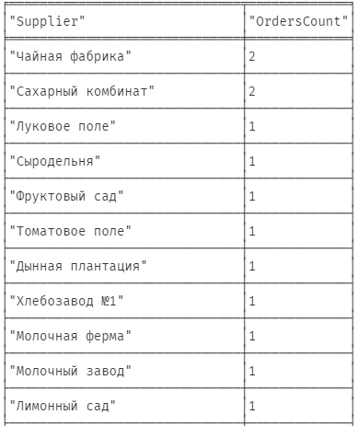
Рис. 95 «Количество заказов»
Выборка суммы продаж по каждому продукту
MATCH (o:Order)-[:CONTAINS_PRODUCT]->(p:Product)
RETURN p.Name AS Product, SUM(o.Quantity * o.Price) AS SalesTotal
ORDER BY SalesTotal DESC
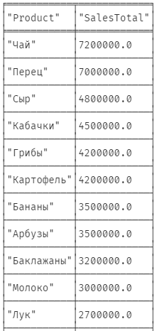
Рис. 96 «Сумма продаж»
Выборка списка всех заказов, содержащих конкретный товар
MATCH (o:Order)-[:CONTAINS_PRODUCT]->(p:Product)
WHERE p.Name = 'Масло'
RETURN o.id_order AS OrderID, o.Date AS Date, o.id_supplier AS SupplierID, o.Quantity AS Quantity, o.Price AS Price
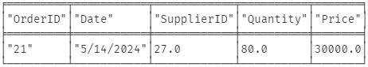
Рис. 97 «Заказы по товару»
Выборка списка всех магазинов, которые получили конкретный товар
MATCH (p:Product)
WHERE NOT (p)<-[:CONTAINS_PRODUCT]-()
RETURN p.Name AS UnorderedProduct
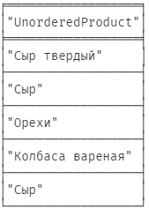
Рис. 98 «Магазины по товару»

5.4.2. Запросы на добавление
Добавление нового поставщика
CREATE (newSupplier:Supplier {
Name: 'Как-то там',
Phone: '89876543210',
Address: 'Тюмень'
})
RETURN newSupplier
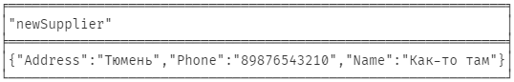
Рис. 99 «Добавление поставщика»
Добавление нового заказа
CREATE (newOrder:Order {
Date: '2023-09-30',
id_supplier: 1,
id_product: 1,
Quantity: 50,
Price: 15000
})
RETURN newOrder
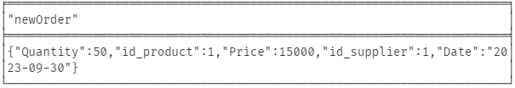
Рис. 100 «Добавление заказа»

5.4.3. Запросы на удаление
Удаление поставщика
MATCH (s:Supplier {Name:'Как-то там'})
DETACH DELETE s

Рис. 101 «Удаление поставщика»
Удаление товара
MATCH (p:Product {Name:'Масло'})
DETACH DELETE p

Рис. 102 «Удаление товара»

5.4.4. Запрос на выборку данных в консоль
Вывод данных об остатках продукции
query_products_balance = '''
MATCH (p:Product)-[:HAS_BALANCE]->(b:Balance)
RETURN p.Name AS Product_Name, b.Quantity AS Quantity
'''
result = conn.query(query_products_balance, db='Bavr')
for record in result:
print(f"{record['Product_Name']}, {record['Quantity']}")
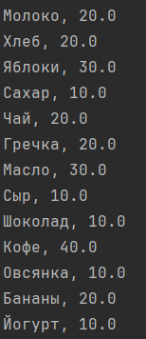
Рис. 103 «Вывод остатков продукции»
Вывод данных сколько товаров в какую дату заказал магазин
query_shops_invoices = '''
MATCH (sh:Shop)-[:ISSUES]->(i:Invoice)
RETURN sh.Name AS Shop_Name, i.Quantity AS Quantity, i.Date AS Date_Invoice
'''
result = conn.query(query_shops_invoices, db='Bavr')
for record in result:
print(f"{record['Shop_Name']}, {record['Quantity']}, {record['Date_Invoice']}")
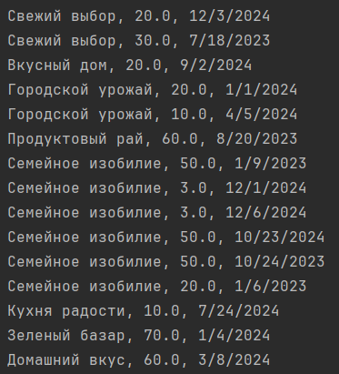
Рис. 104 «Вывод товаров по датам»

